Patrice Moracchini
CSD310-308A(2261-DD)
Nov 19, 2025

Movies: Setup
Module 6.2 Assignment
Pr. Sampson

Running the SQL script:
I screenshotted all the lines on VS Code command line because I was getting an error creating the localhost account, as I use MySQL server version 9.5. I corrected the file this way: 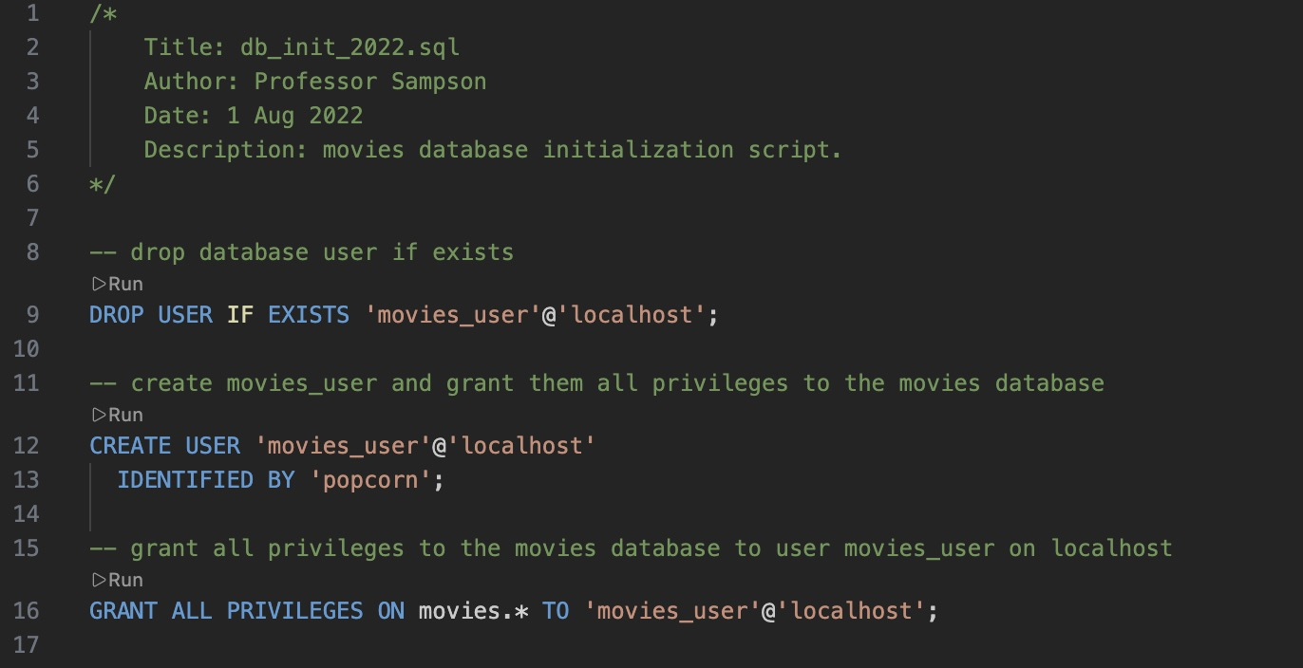

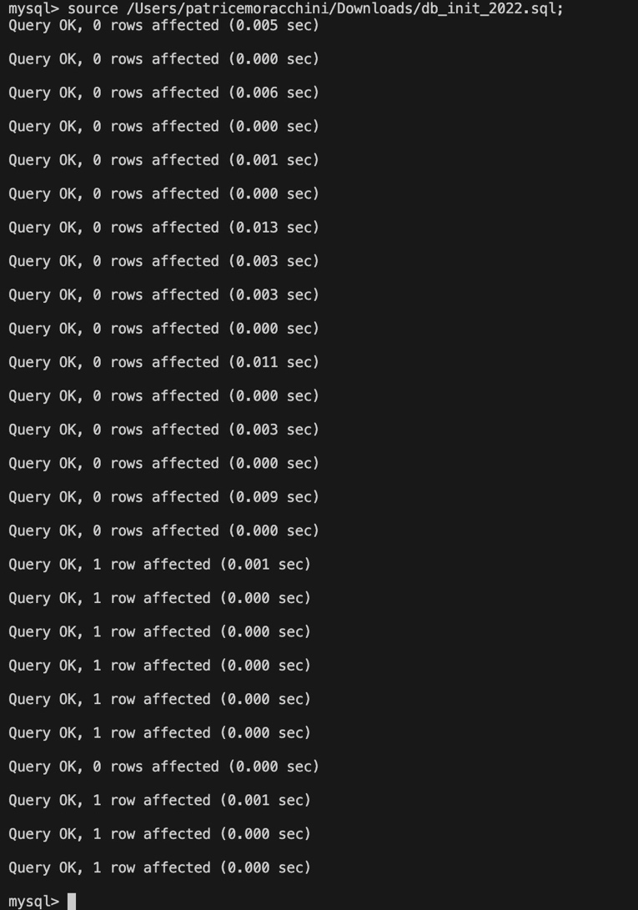
The localhost account has been created with all privileges granted.
List of the Database Tables: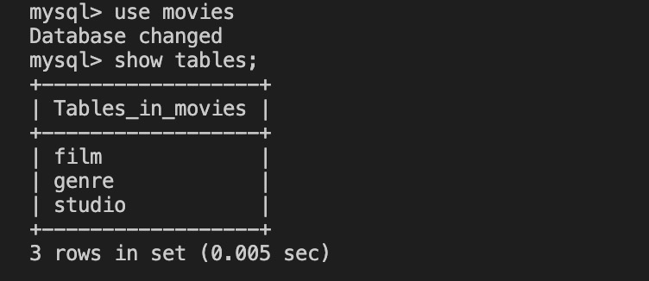
mysql_test.py file results:
